# 46. XHTML and CSS Tutorial - 46 - How to Publish Your Website!

Putting files on the web server so everyone has access to them.

**Uploading file using FTP (file transfer protocol)**

To the folder **public_html** on the server

1. One file (usually the main page) has to have the name “index.html”.

The system will always look for the “index” file.

1. Go to the the hosting web page

Click “FILE MANAGER “

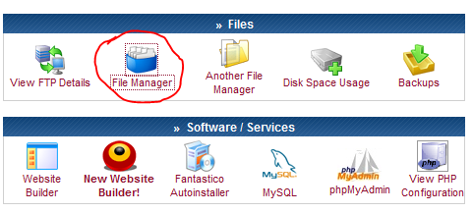

We have to upload all our files to the “public_html” folder

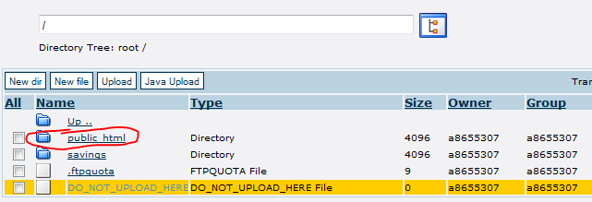

**Go there and click the UPLOAD button**

